Asset Management System -Deployment& working document
Step 1 – Deploy the Package
- The administrator uploads the .sppkg file to the SharePoint App Catalog.
- Steps:
- Upload solution to App Catalog
- Deploy the solution
- Add the application to the target site

Step 2 – Add the App to the Site
- Open Site Contents
- Click Add an App
- Select Asset Management System

Step 3 – Create a Page
- Create a new SharePoint page
- Add the Asset Management Web Part
- Publish the page

Step 4 - Automatic SharePoint List Creation
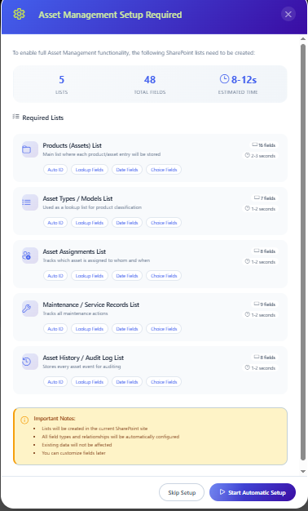

- When the page is opened for the first time, the system automatically displays a List Creation Popup.
- This process creates all required SharePoint lists automatically.
- Lists created include:
  - Asset Types
• Products
• Asset Assignments
• Maintenance Records
• Asset History
- This eliminates manual list configuration and ensures consistent structure.
- Step -5 Asset Type Management Module
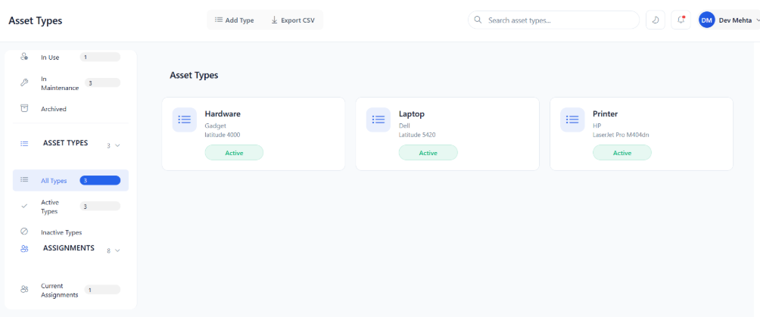
This module allows administrators to define asset categories.
- Examples include:
  - Laptop
• Monitor
• Printer
• Mobile Device

- Features:
• Create asset type:
• Update asset type
• Delete asset type
• View asset type

- Step -6 Asset Management Module:

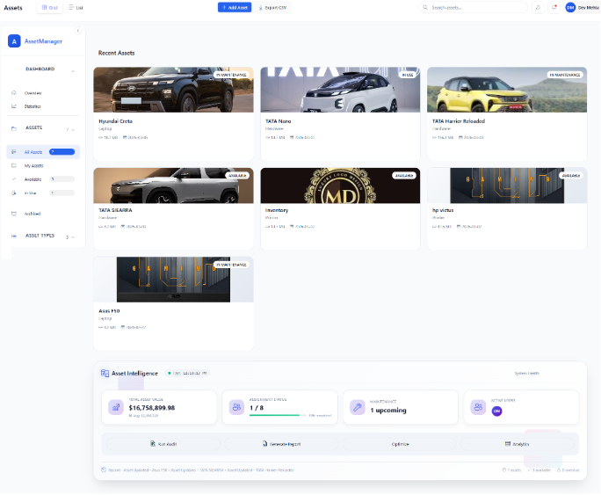

This module allows users to manage individual assets.
- Each asset contains important information such as asset type, purchase date, and status.
- Asset Status Types:
  - Available
• In Use
• In Maintenance
• Retired
• Disposed
- Features:
• Create asset:
• Update asset:
• Delete asset
• View asset list

Step -7 Asset Assignment Module
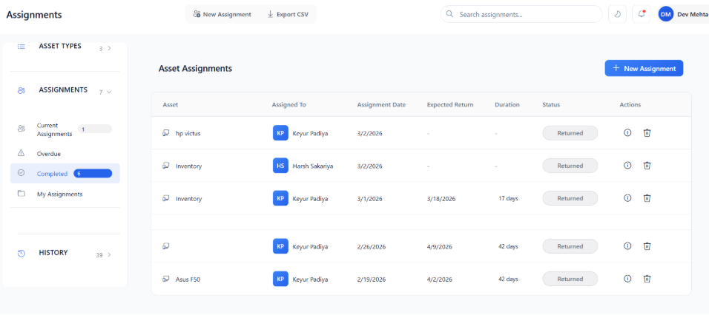
- This module allows assets to be assigned to users.
- It ensures that assets are assigned only when they are available.
- Features:
• Assign Asset
• View assignment history
• Return assigned asset
- Step -8 Maintenance Management Module:

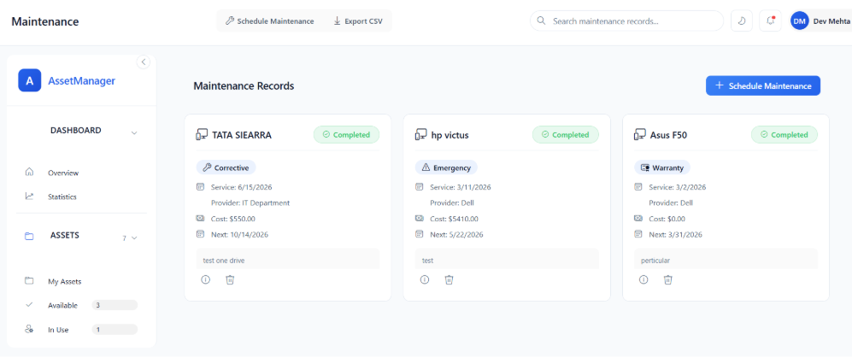
This module tracks maintenance activities for assets.
- Maintenance helps ensure assets remain in good working condition.
- Features:
  - Schedule maintenance
• Update maintenance status
• Record maintenance cost
• Track service history

- Assignment Module Validations

- Several validations ensure proper asset assignment.
- Asset Availability Check
- The asset must be Available before assignment.
- If the asset is already in use, the system checks existing assignments.
- If an active assignment exists, the system prevents reassignment.

- Assignment Date Validation
- Assignment Date cannot be a future date.
- Expected Return Date must be after the Assignment Date.
- Actual Return Date is automatically recorded when returning the asset.

- Return Status Validation
- An assignment can only be marked returned if the status is:
- Assigned or Overdue.
- If the asset is already returned, the action is blocked.

- Maintenance Module Validations
Asset Eligibility Check
- Maintenance can be scheduled only if the asset status is:
- Available or In Use.
- Maintenance is not allowed for:
- Retired assets
- Disposed assets

- Maintenance Status Flow
- Maintenance follows a strict workflow:
- Planned → In Progress → Completed
- Alternative flow:
- In Progress → Cancelled
- Invalid transitions are blocked.

- Service Date Validation
- Service Date can be future for planned maintenance.
- If status is completed, the service date must be past or present.
- Next service date must be after service date.

- Cost Validation
- Maintenance cost must be greater than or equal to zero.
- Cost value 0 indicates warranty service or free maintenance.

Cross Module Validations

- Assignment Return
- When an asset is returned:
- Asset status automatically changes to Available.

- Maintenance Completion
- If maintenance is completed:
- Asset status returns to Available.

- Asset Deletion Rules
- An asset cannot be deleted if:
  - It has active assignments
• It has pending maintenance

History Tracking Module

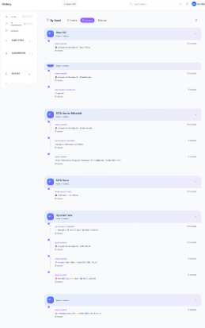

- The system records every important action in the History Section.
- History includes:
• Asset Creation
• Asset updates
• Asset deletion
• Asset assignment
• Asset return
• Maintenance scheduling
• Maintenance completion
- This provides a complete audit trail.
- Dashboard and Analytics:
The system includes a dashboard that provides an overview of asset statistics.
- Dashboard information includes:
  - Total Assets
• Available Assets
• Assigned Assets
• Assets in Maintenance
  - Portfolio Value (Total Purchase Price)
  - Utilization Rate (%)
  - System Health Score (%)
  - Upcoming Maintenance (next 7 days)

- Charts and Data Visualization
Three chart types are used in the dashboard.

- Donut Chart 📊

- Displays asset status distribution.
- Example: Available vs In Use vs Maintenance.
- Hover to see exact counts and percentages
- Click on legend to filter data

- Bar Chart 📊
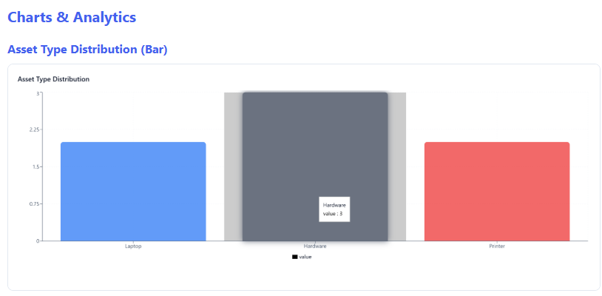
- Displays asset statistics such as asset types or maintenance counts.
- Shows comparison between different categories

- Asset & Activity Timeline (Combination Chart) 📊

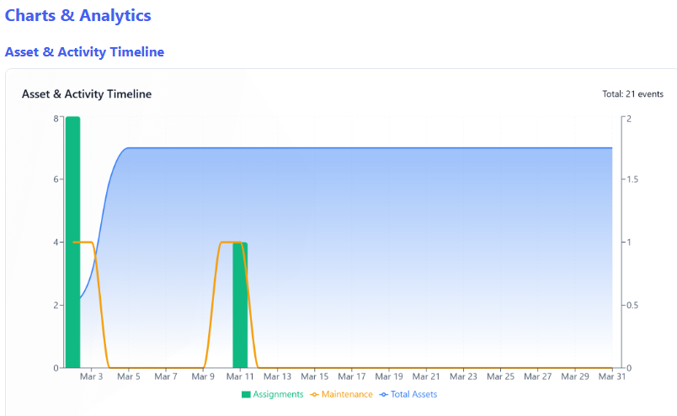
- Shows asset activity trends over time.
- Examples:
- Assignments over time
- Maintenance frequency
- Toggle between different data series (Assets/Assignments/Maintenance)
- Filter by time range (Week/Month/Quarter/Year)

- Export Functionality

- Export data as CSV from any view
- Export charts as PDF
- Print dashboard with charts
- Share dashboard summary via Web Share API

- Export Options

- Assets list → CSV
- Assignments → CSV
- Maintenance records → CSV
- Charts → PDF/Print
- Dashboard summary → Share/Copy

